**Door Monitor Project- Final Deliverable**

**May 6, 2023**

Caidence, Darri, Zoralla

<https://github.com/darristuber/CSC-102-FINAL-PROJECT.git>

**Project Summary**

The goal of this project is to capture, store, and display photos taken when motion is detected by the PIR sensor. When motion is detected in front and to the sides of the PIR motion sensor, a photo will be captured. The photo will be stored in a local folder and displayed on a GUI application with the date and time. The user will be able to look back at the images any time after they have been captured using the GUI. The GUI also allows the system to be turned on and off.

**Goals and Objectives**

* Capture a photo when motion is detected near the sensor
* Store the photo on a local storage device
* Display photos on a GUI application

**GPIO Goals**

* Capture an image upon sensing motion during “off periods” using a camera
  + We will now be keeping the camera on, and it will only capture a photo when motion is detected
* Utilize other GPIO components (i.e. Breadboard, Pushbuttons, Jumper Wires)
  + The hardware does not require the use of the breadboard or push buttons. The hardware is able to connect to the Raspberry Pi directly.

**GUI Goals**

* The GUI application will display single images and allow the user to skip through images saved on the file.
* The GUI will allow the user to turn the system on and off.

**Future Development Plans**

If we were to continue working on this project, we would be interested in adding sound, video, and a way to notify the user when an image has been captured. Originally, the video function was not working with our camera, therefore we could only capture photos. If we expanded to video, users would know exactly what is happening in front of the monitor and know if there is a legitimate threat. By adding a way to notify users when motion is detected, the user can act immediately rather than wait until they browse through the system. Furthermore, rather than alerting the individual user, we could expand to notify emergency services for extreme circumstances such as increased temperature or loud noise. If we went that route, we would need to include a thermal sensor and sound sensors. Adding this feature would make our project more meaningful because it could be used as a security device rather than a motion detector.

**Lessons Learned**

Throughout this project, we have learned how to set up and operate a Raspberry Pi camera and PIR motion sensor, and generate a code that suits our needs. Through the project, we were able to write object-oriented programs using Python, use data structures to store and play back images, practice configuring devices to the Raspberry Pi, and worked with our group to create a project with a presentation. Furthermore, we learned to use the maker space to laser print an enclosed structure to house the camera and motion sensor. Through this experience, we have learned how to work in a group and problem-solve using peers and mentors. The biggest obstacles we faced were the difficulties in creating code from scratch and figuring out how to implement a GUI. We were able to build our code with the help of peers and created the GUI referring back to previous activities done in class.

**Layout**:

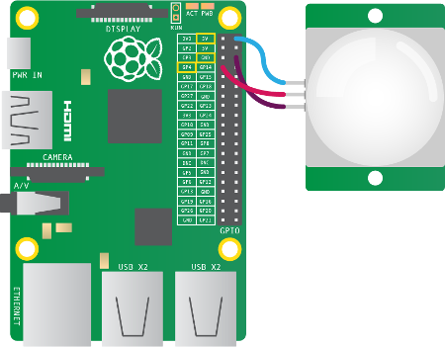 PIR motion sensor

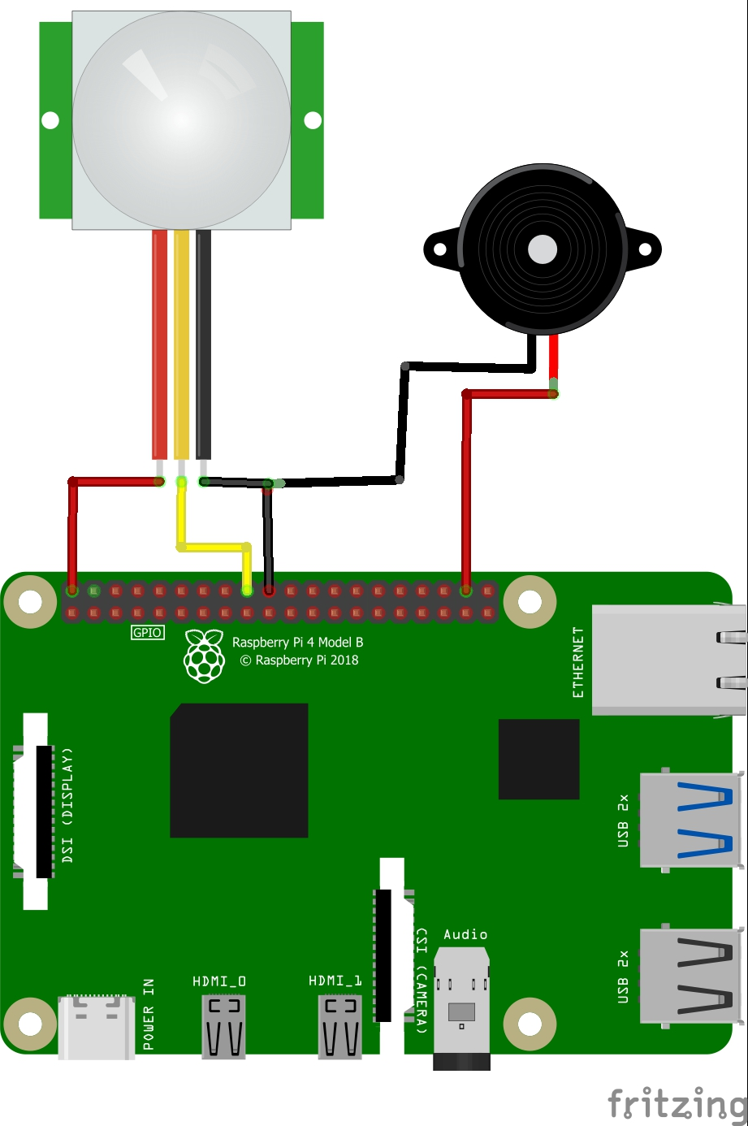

Raspberry pi setup with pi camera and motion sensor

